**Ideation Phase**

**Brainstorm & Idea Prioritization Template**

|  |  |
| --- | --- |
| Date | 04/11/2022 |
| Team ID | PNT2022TMID19703 |
| Project Name | AI Powered Nutrition Analyst for Fitness Enthusiasts. |
| Maximum Marks | 4 Marks |

**Step-1: Team Gathering, Collaboration and Select the Problem Statement**

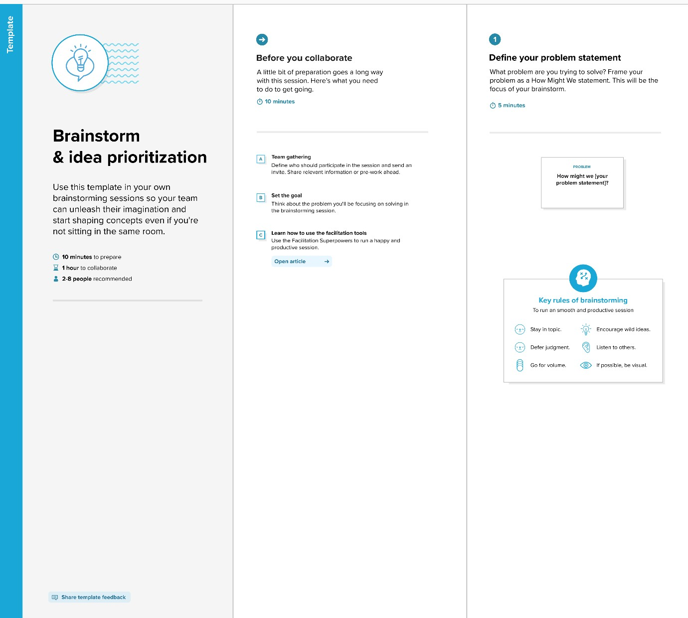

**Step-2: Brainstorm, Idea Listing and Grouping**

sff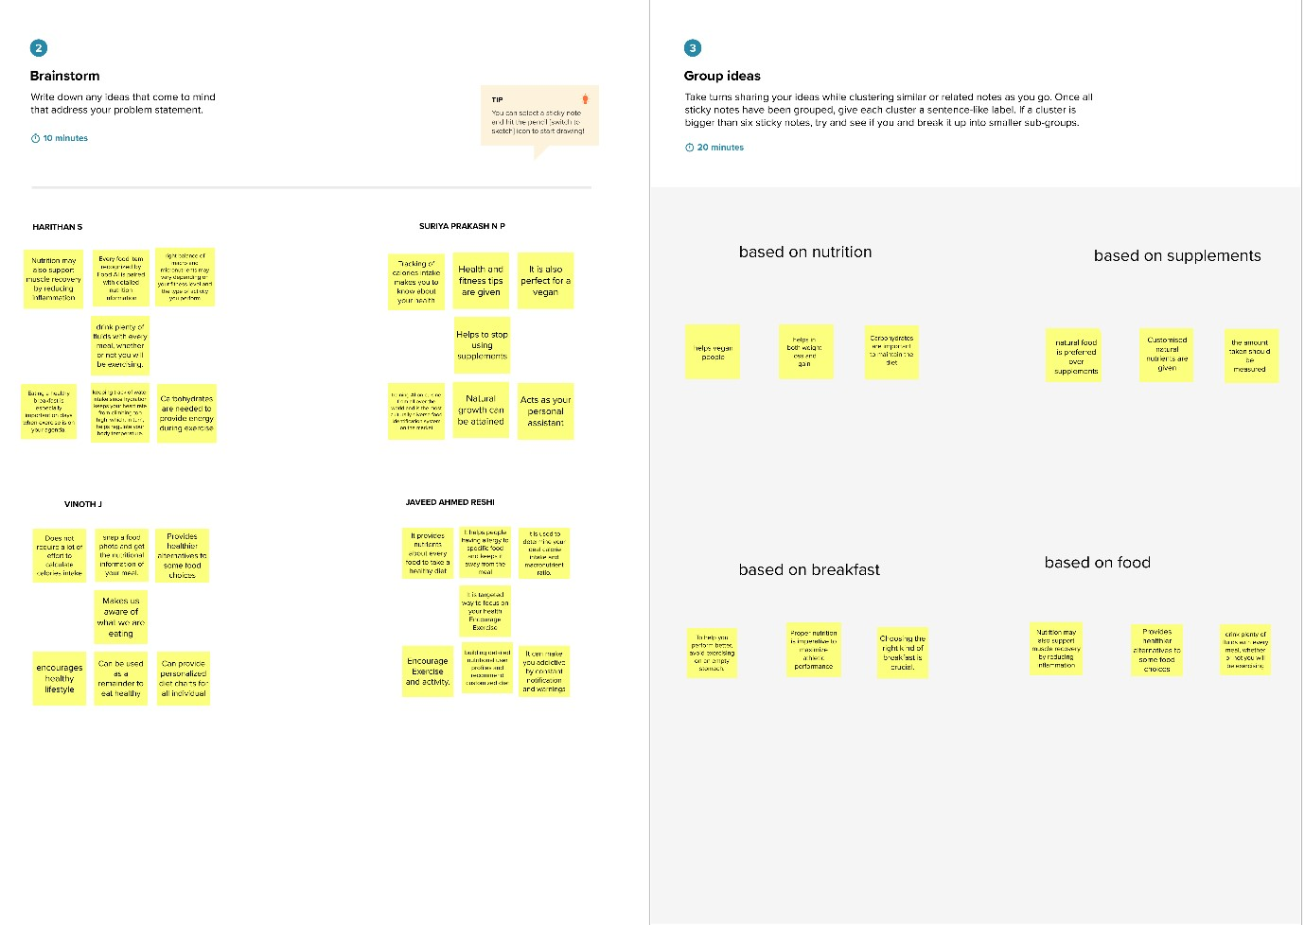

**Step-3: Idea Prioritization**

